**All about UTC**

UTC ( Universal Coordinated Time ) is a standard time respect to which all other time zones are made.

UTC is calculated by it’s two main components

1. International Atomic Time
2. Universal Time

(TAI) : International Atomic Time is caculated by combining time of more than 200 atomic clocks world wide. So it’s very accurate

( UT ) : It is determined by the help of earth’s rotation

See example below



Accoding to UTC standard today’s time is shown above

Now all other time zones are made w.r.t UTC

So all other time zones are either ahead or behind the UTC

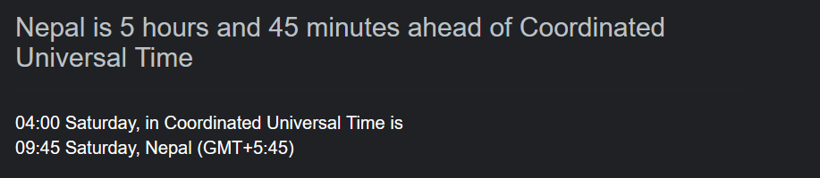

In Nepal our time is 5:45 ahead of both UTC and GMT

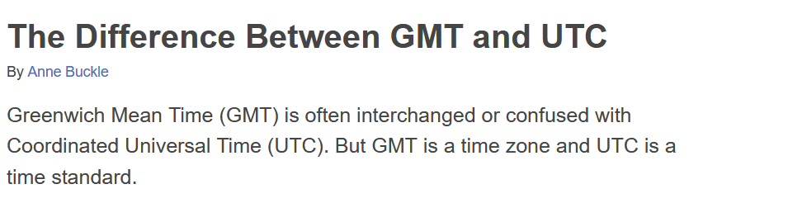

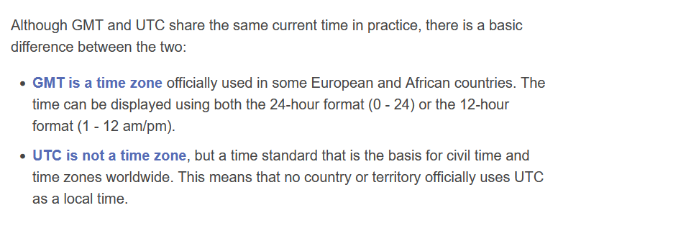

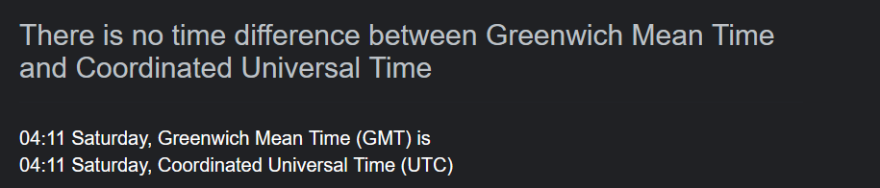

There is no Such difference but while UTC is a standard time GMT is an actual time zone used by certain Nations that has exactly same time as UTC, while most countrie’s time zones are either certain hour ahead or behind the UTC time, GMT time is o hour ahead or behind, it is exactly same time as UTC

All about ISO

Different countries have their own standard for writing the date

So the International Organization for Standardization purposed a way to write a date format, that format is called the ISO format of date

There are certain rules

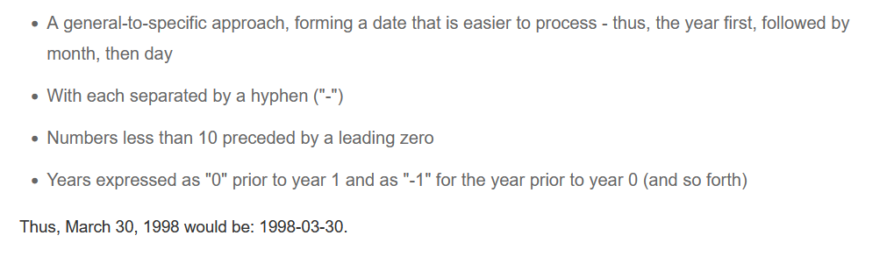

Now the methods in JS for Date

toUTCString()

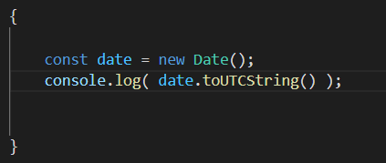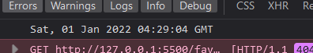

returns the date in string in UTC standard

toISOString()

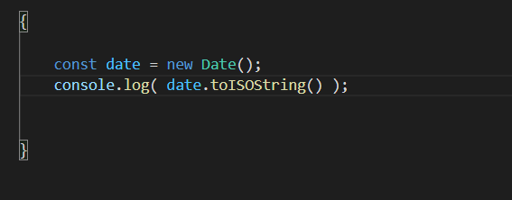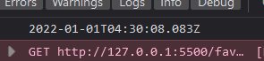

returns the date in string in ISO standard format

Here T means year-month-day finished and now time begins

Z means that the date is in UTC standard form

toDateString()

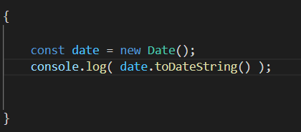

it returns only date in easy to read form, it doesnot give us time only date

**The ISO format of date is also a strict standard in Javascript**

So we can give argument to Date() constructor in ISO string form to make a date object

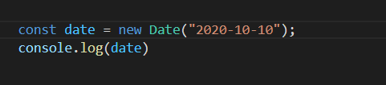

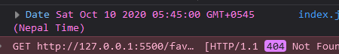

Here we do not specify the time zone so the browser’s time zone is considered while displaying output

in ISO format we can even omit either day or month or both day and month and can only provide year as argument to the Date ( ) constructor

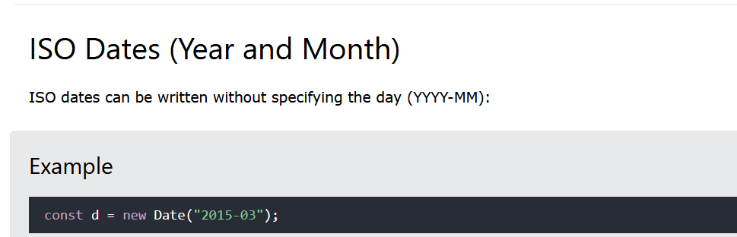

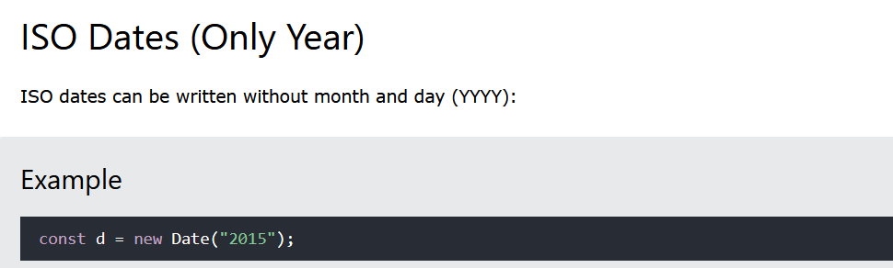

**The full ISO format is YYYY-MM-DDTHH:MM:SSZ**

So we can also give this whole argument to the Date ( ) constructor

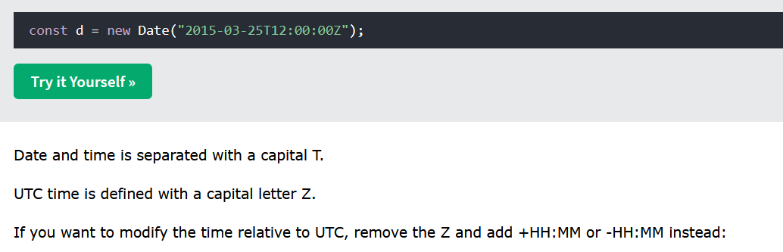

Format other than ISO are not standard in JS so avoid them

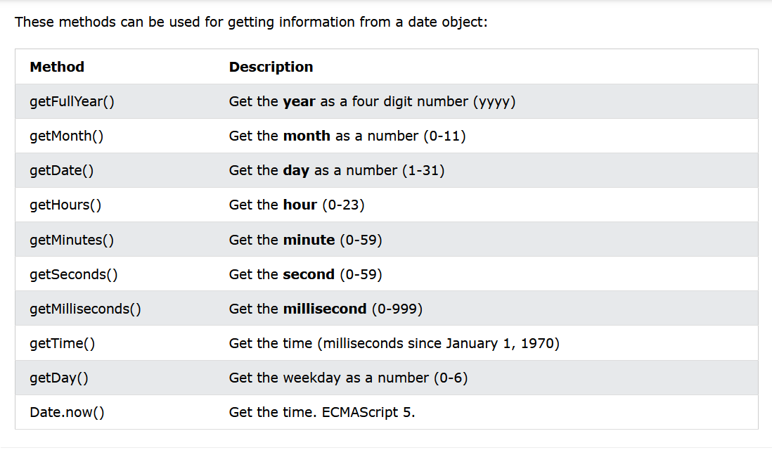

getDate ( )

This method will give us the day of the month

Also that last one, Date.now ( ) is same as getDate( ) method

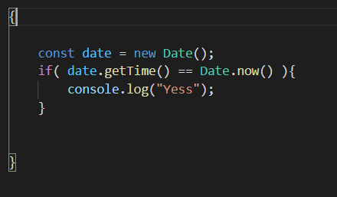

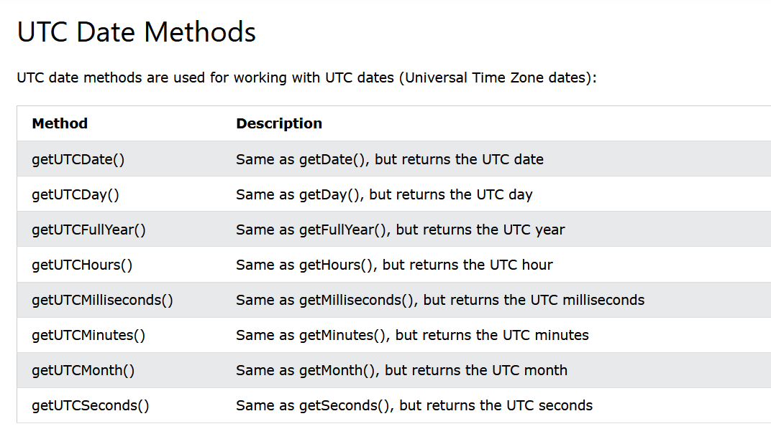

These does same as above but they returns in the standard UTC form

We can also set the year, month, day, hours, minutes by similar methods 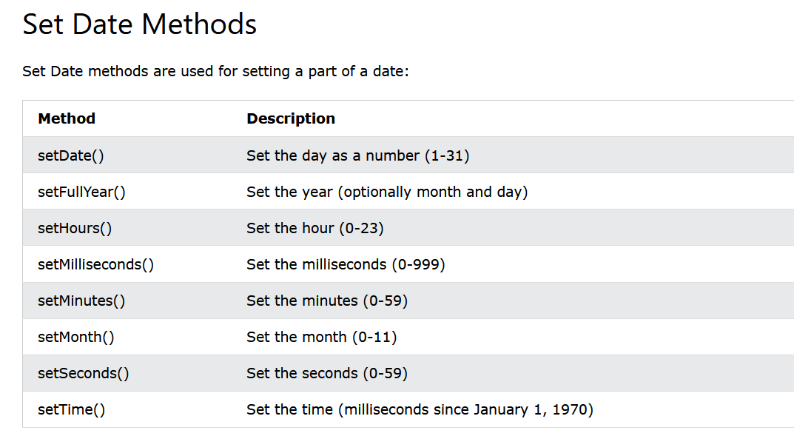

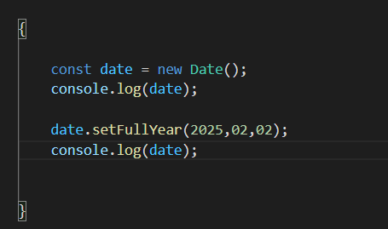

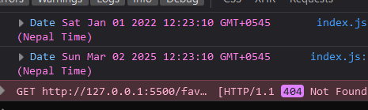

Surprisingly the setFullYear ( )

can also set the month and day of the month as shown above